**Exploring Factors Influencing Data Science Job Salaries A Tableau Visualization Study**

**Problem Statement:**

In the rapidly evolving landscape of data science employment, understanding the dynamics of job salaries is essential for organizations and professionals alike. Much like ABC Super Mart aims to optimize its operations and revenue by identifying key product categories, stakeholders in the data science industry seek insights into factors driving salary disparities and potential areas for strategic intervention. This project endeavors to analyze a comprehensive dataset encompassing various attributes such as experience level, employment type, and remote work ratio to discern patterns influencing data science job salaries. By identifying trends and factors that contribute to salary discrepancies, the project aims to provide actionable insights to organizations for optimizing compensation structures and talent acquisition strategies. Similarly, professionals navigating the data science job market can benefit from understanding salary dynamics to make informed career decisions. Through this analysis, the project aims to empower stakeholders in the data science community to make strategic choices that maximize their value and contributions in the field.



**Objective:**

An objective is a specific, measurable, and time-bound goal or target that an individual or organization aims to achieve. Objectives are typically set to guide actions and decision-making towards desired outcomes. They are often a part of broader goals and help to clarify what needs to be accomplished within a certain timeframe. Objectives should be realistic, achievable, and relevant to the overall mission or purpose, providing a clear direction for efforts and resources.

**Task:**

* The primary objective of this project is to analyze the distribution of companies hiring for data science roles across different sizes and locations.
* The management aims to gain insights into the concentration of data science job opportunities, as well as to identify potential patterns and trends based on company size and location.

**Dataset**: [Link](https://www.kaggle.com/datasets/ruchi798/data-science-job-salaries)

**Solution Development Procedure:**

* Once we load the data into Tableau Desktop.
* Select pie charts on Marks card .

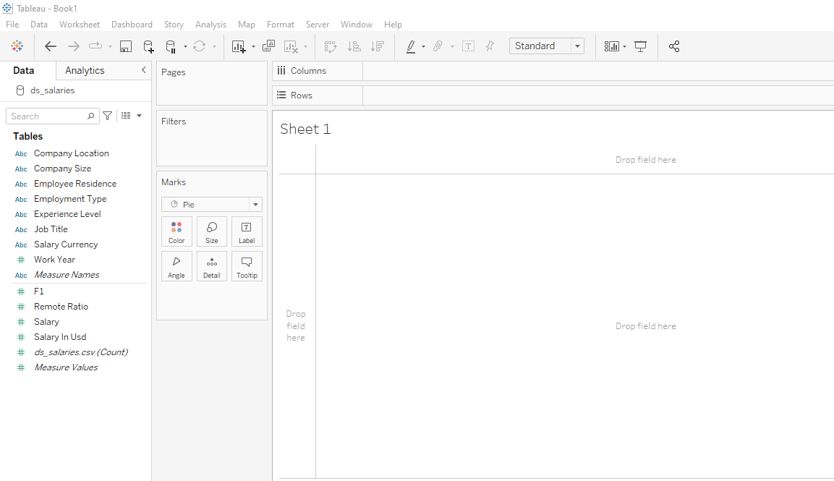

* Select Drag Company Size into colours in Marks card.

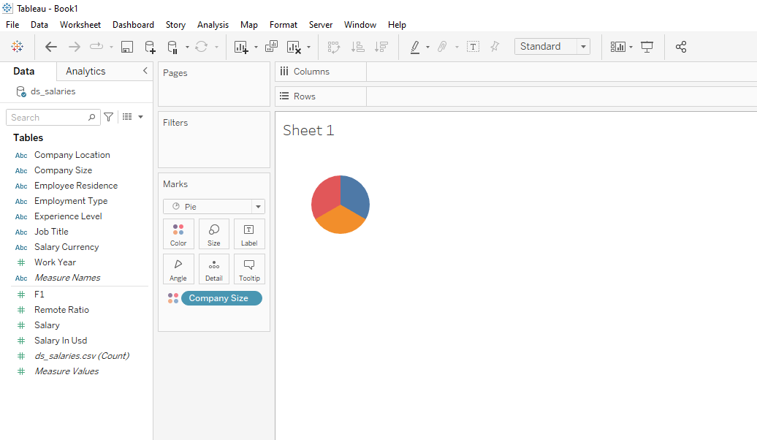

* Drag again your Company Size into Size in Marks Card.

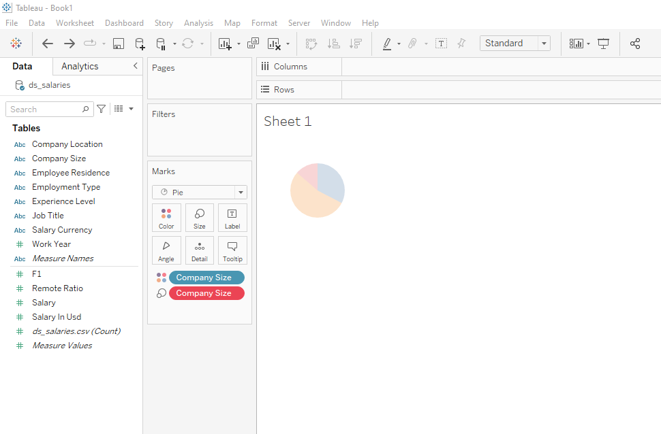

* Convert your Company Size to Count Measure , and Drag your Company Size to Label and also Drag your Count of Company Measure to Label.

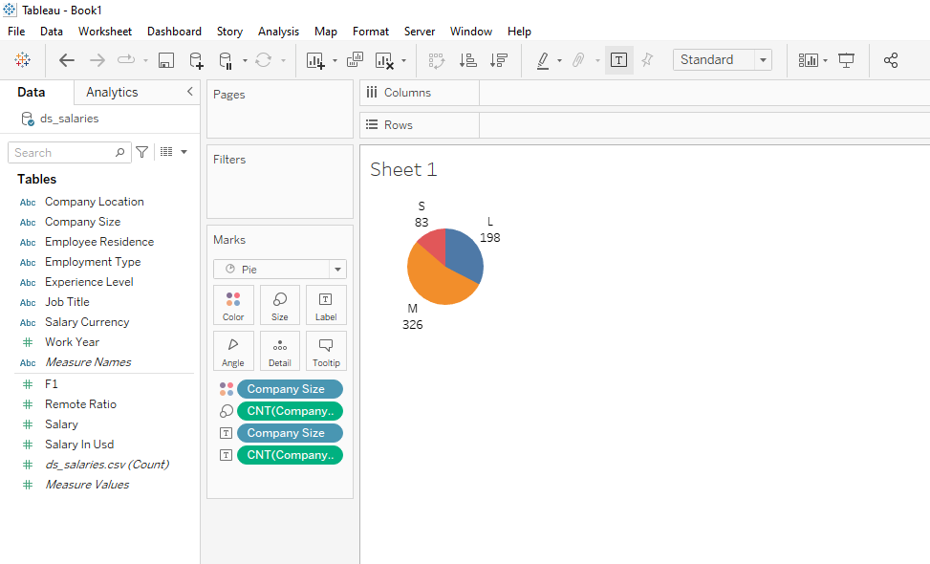

* Double Click on Rows , enter zero and that makes the sum of zero by pressing enter , also drag the same sum of zero to become two double pie charts.

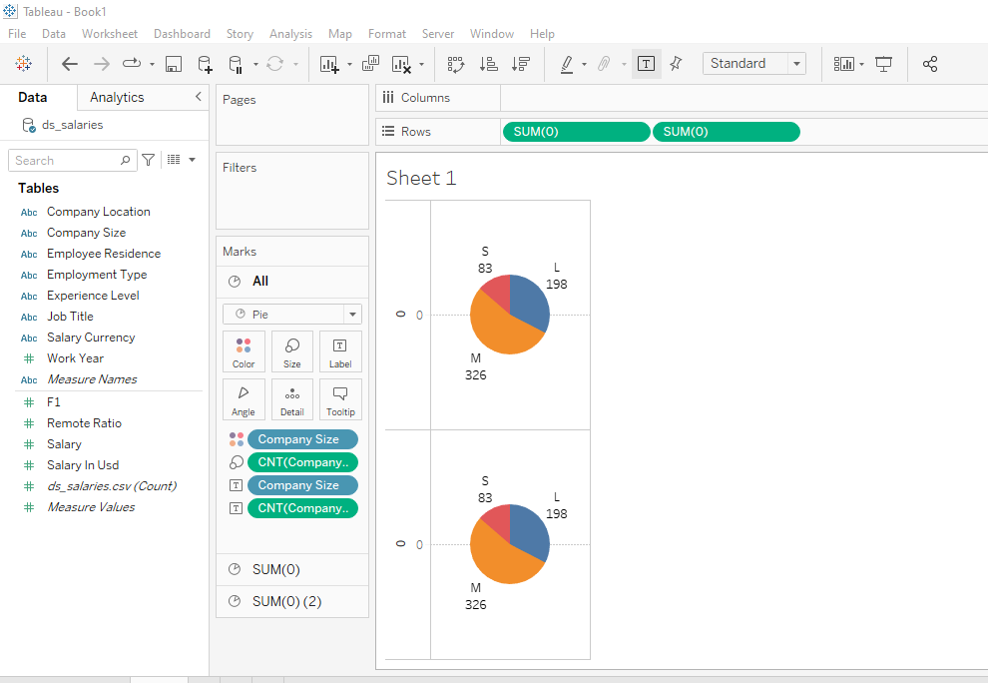

* Adjust the size of your pie charts , and click on the Dual axis on one of the sum of zero option to combine both pie charts as a Donut Chart.

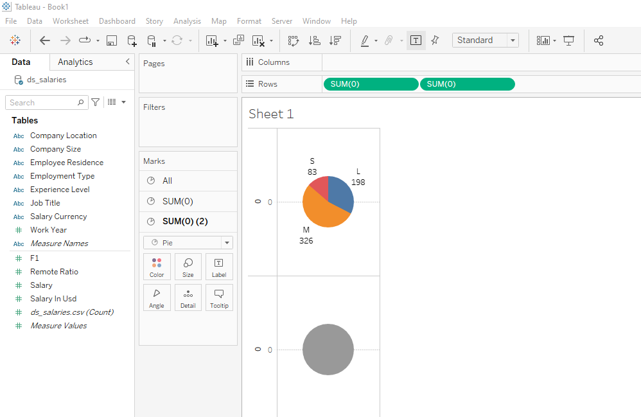

* Remove the Columns for Second Pie Chart.

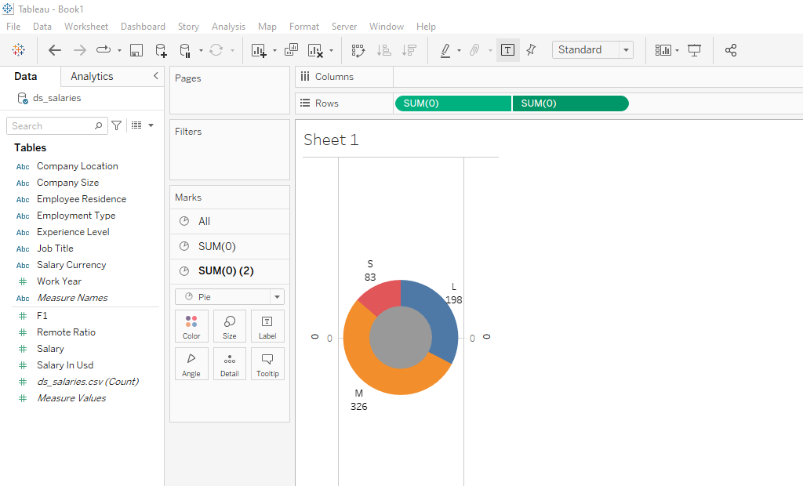

* To remove the zeros at the corners of your sheet , click on the zeros and it displays a box which consists of custom as title , remove the zero as title in general section.

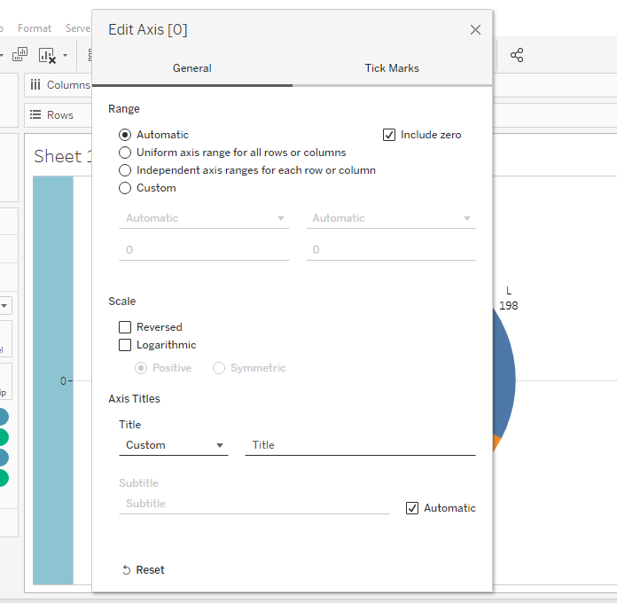

* In the Tick Marks Section choose your option as None.

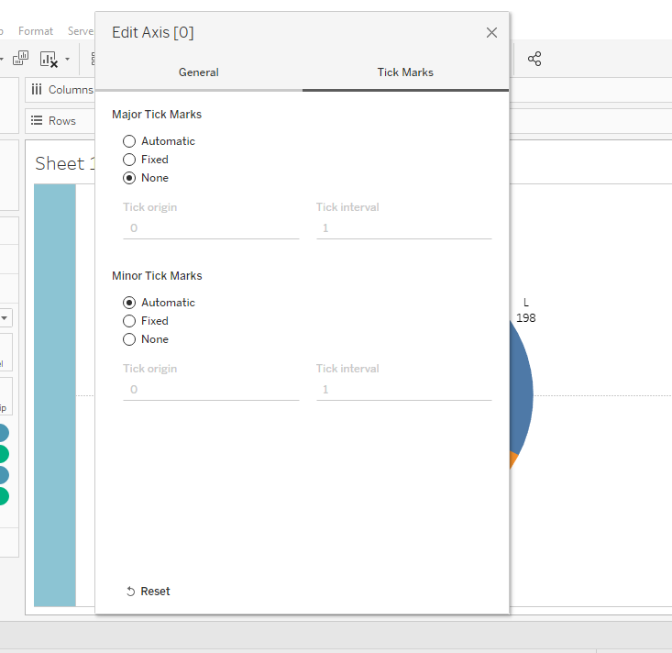

* Choose your Company Location by Dragging the Company Location Column into Filters Section.

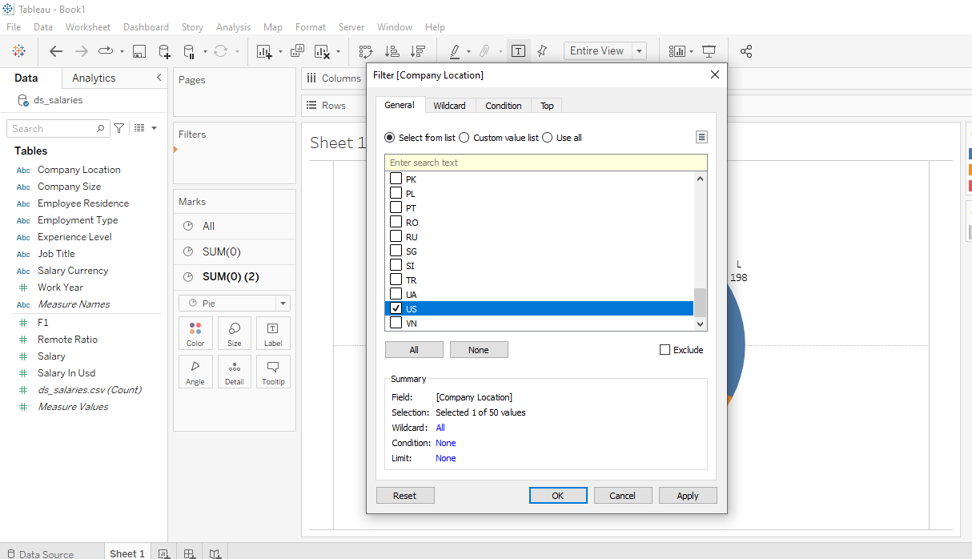

* Select Single Value Dropdown for your Filters while showing it on right side of the sheet.
* Choose Percent of Total as your data value to be displayed for the Company Sizes and make your Donut Chart to represent it in Entire View.

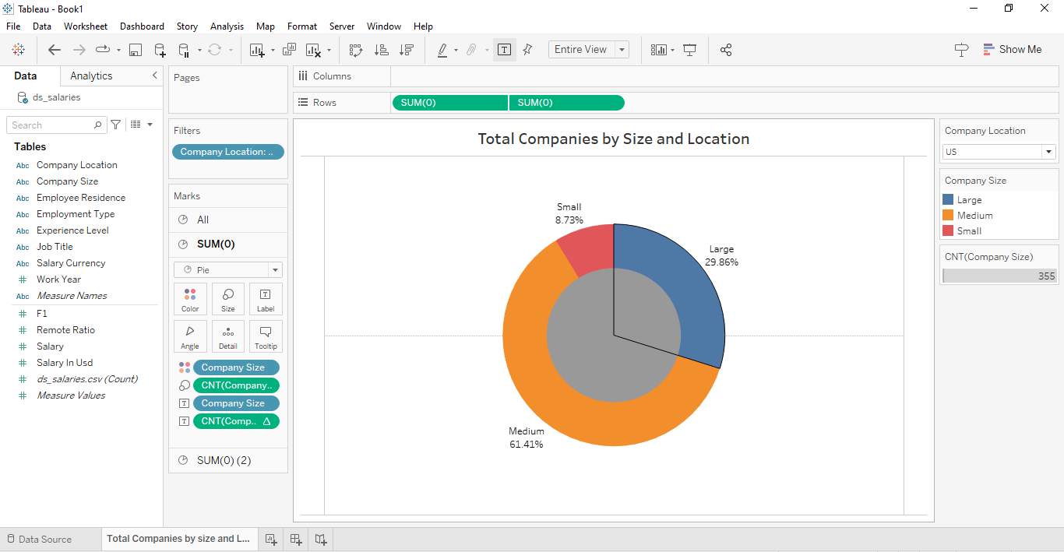

* Format your Colours and Borders according to the title box and Donut chart.

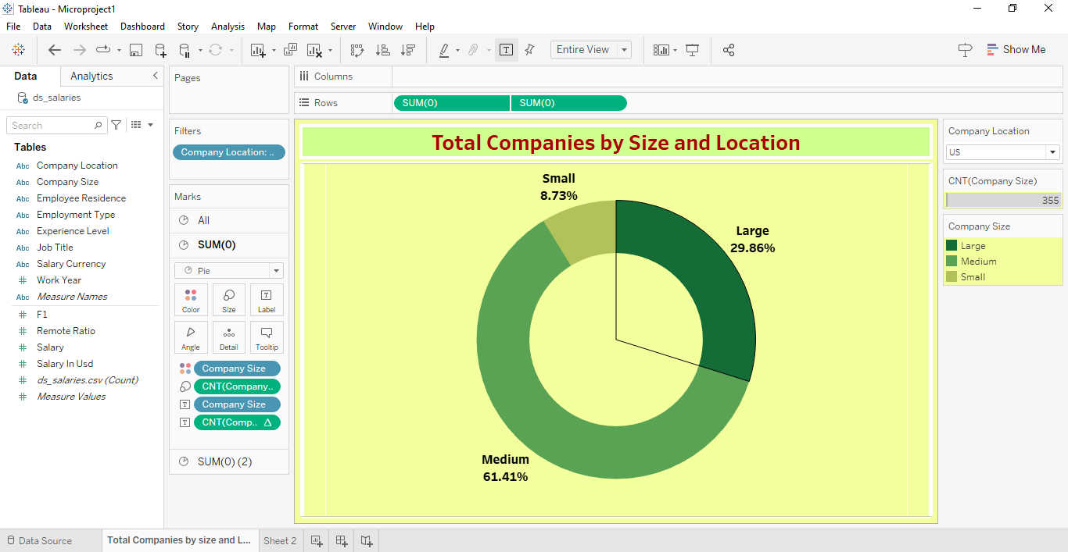

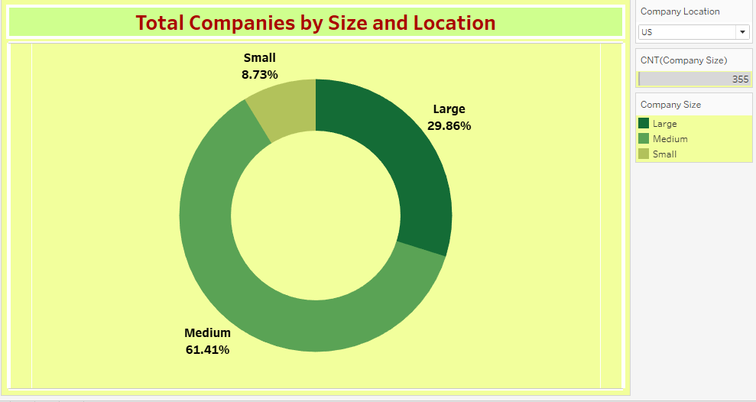

**Insights:**

Insights refer to valuable and meaningful understandings or perceptions gained from analyzing data, information, or experiences. They provide deeper understanding, clarity, or revelation regarding a particular subject or situation.

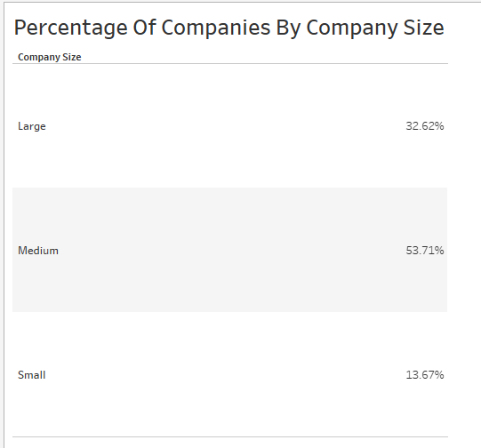

.

* The data illustrates a substantial presence of medium-sized companies, comprising approximately 53.71% of the total number of companies. This suggests a significant portion of the data science job market is represented by mid-sized organizations, potentially offering ample opportunities for job seekers.
* Combining medium and large-sized companies, they account for approximately 86.33% of the total number of companies. This underscores the importance of targeting mid to large-sized organizations in recruitment strategies or job searches, as they collectively offer the majority of data science job opportunities within the analyzed dataset.

**Conclusions :**

Conclusions are logical deductions or decisions drawn from observations, evidence, or analysis. Conclusions are often based on the findings or results of a study, experiment, or evaluation, and they aim to summarize key insights or outcomes. Effective conclusions should be supported by evidence, logical reasoning, and critical thinking, leading to well-informed decisions or actions.

* The visualization reveals a distribution of data science job opportunities across different sizes of companies, highlighting the prevalence of employment opportunities in small, medium, and large organizations.
* It indicates the geographical distribution of job opportunities, providing insights into regions with the highest concentration of data science roles.
* By understanding the distribution of companies by size and location, organizations can tailor their recruitment strategies to target specific regions or company sizes where job opportunities are most abundant.
* This visualization serves as a foundational tool for both employers and job seekers to make informed decisions regarding recruitment and job search strategies, ultimately optimizing the efficiency of the hiring process within the data science job market.